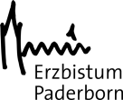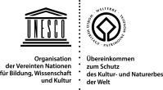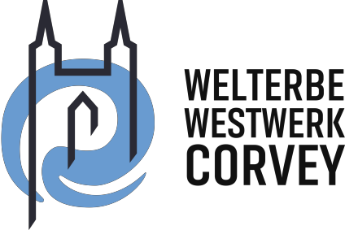
www.WelterbeWestwerkCorvey.de

World Heritage Site Westwerk Corvey
Invitation to a virtual journey into the history of an important monastery site
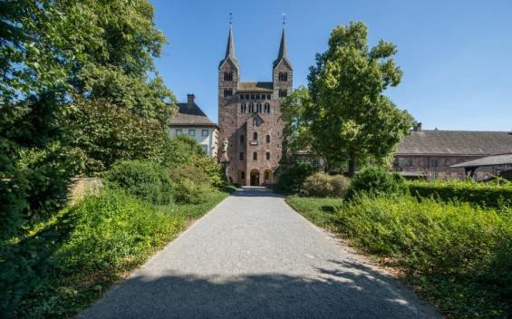
The World Heritage Westwerk Corvey is a fascinating edifice and contemporaneous witness to European history. Even today, it still reflects the erstwhile powerful political and religious influence that the abbey exercised from its location on a bend in the Weser river. The imposing cloister complex was a powerful spiritual, economic, political and cultural centre of the Middle Ages, with emperors and kings as frequent guests. Faith was put into practice at Corvey, and Christianity was disseminated from here into the far reaches of northern Europe. In its role as an imperial abbey, the Benedictine monastery and its prized library, famed scriptorium and school were amongst the most important promulgators of Christian culture in the Frankish Empire. World history was made at the Weser river bend, and the architecture mirrors its rich legacy.

A Unique World Heritage Site
UNESCO granted the Carolingian Westwork and Civitas Corvey the status of a World Heritage Site in June 2014. The Civitas ̶ the medieval monastery complex ̶ is preserved as an archaeological monument and lies hidden beneath the Baroque palace grounds. In contrast, the two towers of the Westwerk, which was built between 873 and 885, are visible for miles around. It is the only edifice of its kind that still exists today and essentially typifies what the people of the 9th century saw.

The Digital Celestial City
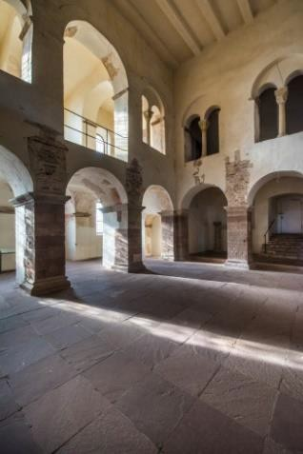
Restorers and art historians, archaeologists, monument conservators, architects and climate specialists are currently working to secure delicate structural elements. At the same time, leading international experts have begun work on making the Weltwerk accessible digitally. Von Engeln bewacht – In der Himmelsstadt (Watched Over by Angels - In the Celestial City) are multi-media installations currently being developed to bring this charismatic place alive in a unique experience in the coming years. Augmented reality applications will also merge images, sound and speech – transporting visitors to the monastic world of the Middle Ages. These apps will reveal the architectural secrets and unmatched frescoes on the upper floor, in the magnificent Johannischor (St. John's Choir). Digital media make it possible to reconstruct parts of the original coloration and the Carolingian architecture, enabling these to be experienced in three dimensions.
Corvey, March 2018 www.WelterbeWestwerkCorvey.de

PASTORALVERBUND CORVEY PRESSEKONTAKT
Marktstraße 19, 37671 Höxter Waltraud Murauer-Ziebach
+49 (0) 52 71 4 98 98-0 +49 (0) 231 1 77 06 46
info@pv-corvey.de, www.pv-corvey.de w.murauer@arthema.de

